Number of Steps to Reduce a number to Zero

Platform: LeetCode
Language: C
Module 3, Question 2

Problem Link
https://leetcode.com/problems/number-of-steps-to-reduce-a-number-to-zero/

Problem Statement
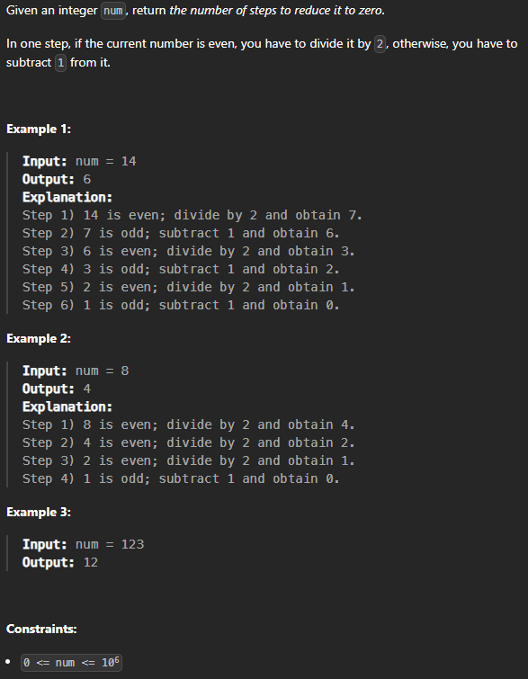

C Code
int numberOfSteps(int num) {
int steps = 0;
while (num > 0) {
if (num % 2 == 0)
num = num / 2; // even: divide by 2
else
num = num - 1; // odd: subtract 1
steps++;
}
return steps;
}

Screenshot of Successful Submission



